C.O.C.
Cars on Campus, Lease a Car as a College Student

Business Plan & Mobile Application Design Document



MIST 2090 Project by:
Adelaide Arthur
Carly Hybarger
Larkin Rief
Laney Dugan
Graham Lee
Table of Contents
Executive Summary 3
C.O.C. Business Model 5
Cars on Campus Business Model 5
Business Model Canvas Explanation 6
Project management 7
Written description of project steps 7
Work Breakdown Structure Diagram 8
Business Process Model 9
Application Wireframe Models 10
Data Management 11
Data Model 11
Written Explanation 12
Final Reflections 13

Executive Summary
Cars on Campus provides the unique service tailored to the needs of college students when it comes to transportation on campus. This is in the same industry as other car leasing firms; however, these companies do not have a market for under 25-year-old people, unlike Cars on Campus. Currently, there are limited solutions when it comes to leasing a car as a college student due to the government regulation on car leasing age. Additionally, students often face financial obstacles and complications in regard to having a vehicle far from their homes. Out-of-state students experience difficulties with bringing cars to their school, as many of these students have at least ten-hour drives to their universities. C.O.C. offers a much simpler means of leasing a car by way of app, especially when compared to other major corporations.

C.O.C. Business Model

Cars on Campus Business Model

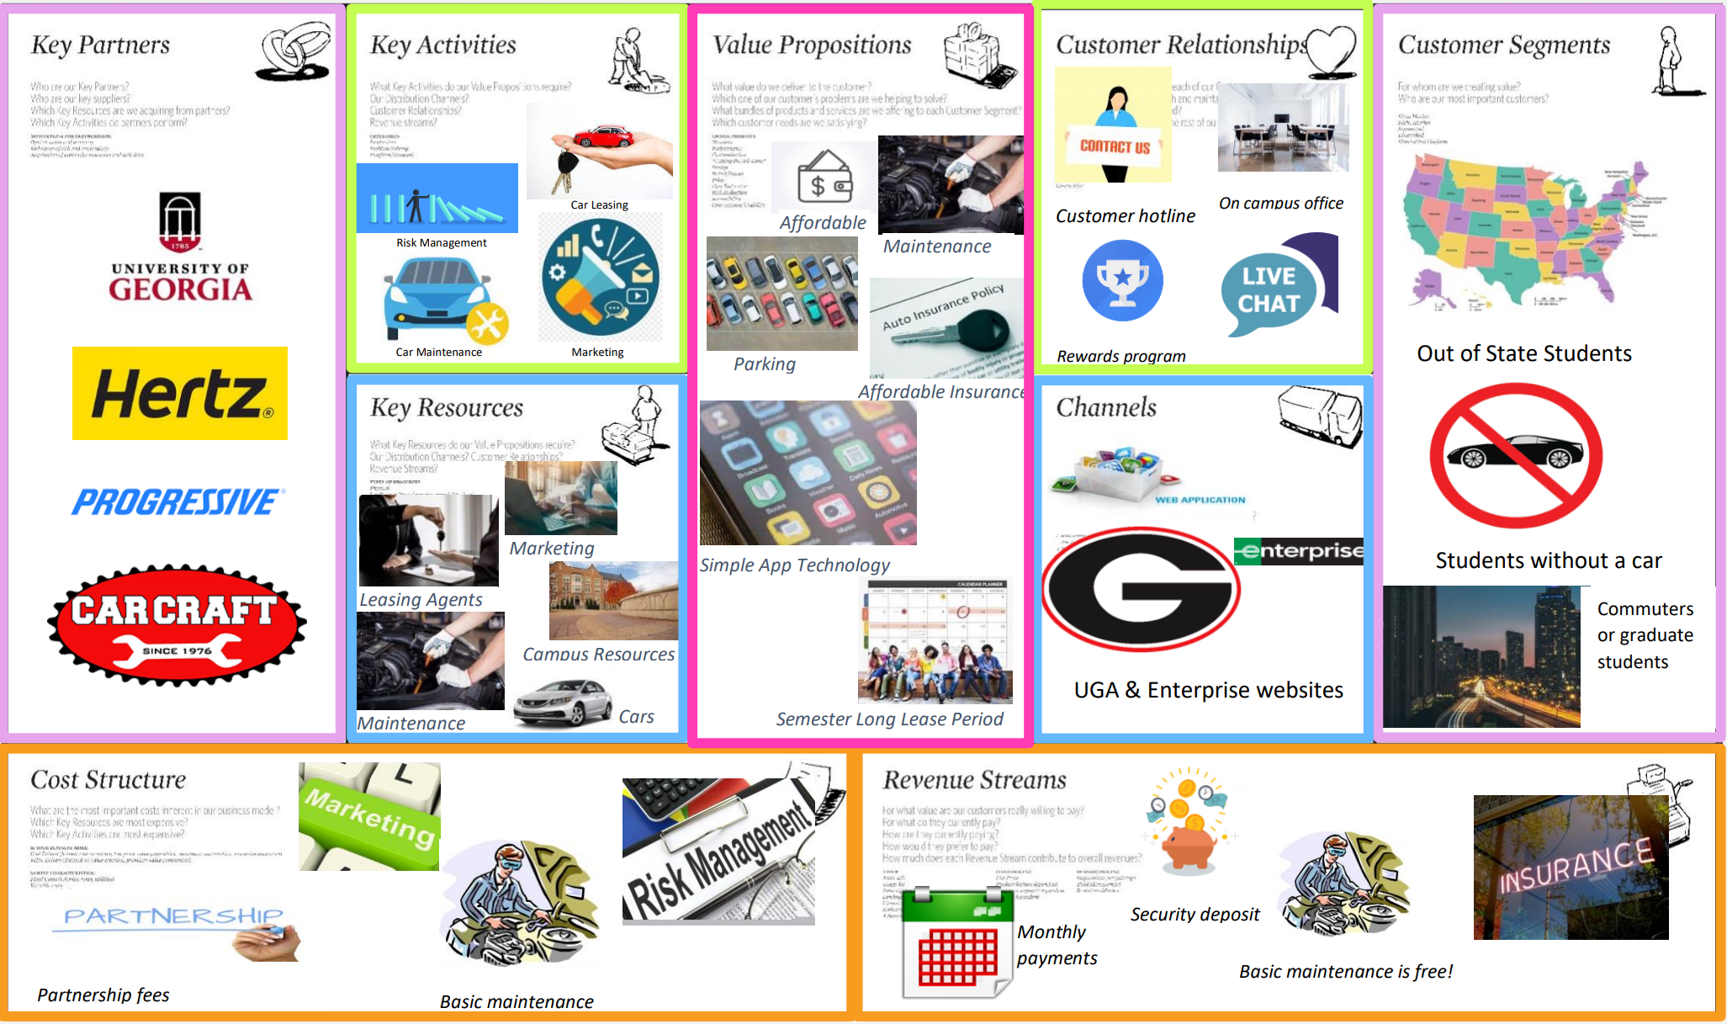

Business Model Canvas Explanation
Our main value proposition is being aimed towards college students. We aim to provide leases that can start and end around semester start dates. We also aim to provide reasonable prices along with maintenance and affordable insurance options. Our target market is college students without cars. Whether this is people from out of state that are unable to bring a car from home, or people that could only afford to lease a car. Designing our platform so leases can start and end with semester dates is an important part of our value proposition. This would allow people that might be graduating a semester early or studying abroad to have a car for the rest of the time they are on campus and not have to pay while they’re not on campus. Our revenue model is based on cash coming in from monthly payments and security deposits. Some key resources we will need to make our business model work include good connections with a maintenance provider, insurance company, and car dealership. We also want to include a good parking plan, which we would need a good relationship with the university parking system to do.

Project management

Written description of project steps
A large part of our value proposition is our consumer-friendly app. Naturally, creating an effortless, consistent app is not an easy task. Using a Work Breakdown Structure model, we can take a complex project and divide it into specific line items. We first sectioned the goal into three large items which then had more specific steps below. Our large tasks include collecting and analyzing user data, developing the software and finally, testing the results and implementing it into the market.
Titled “User Research”, our first step is to collect data about our desired demographic and customer base. Using this information, we will conduct focus groups introducing our concept to our potential clientele. Finally, we will use this data to guide our app design and interface.
For our next large step, we will use the collected research to develop our app. This means first, create the user-friendly app to be both functional and effortless. Then, code and design the backend of the app including analytic abilities and insured protection of private information. Once a complete version has emerged, we plan to run a beta version of the app.
This beta version is going to be used for testing and reworking, which is our third large task. By implementing a beta version, we can correct any immediate flaws and clean up user interface. This is also where our design aesthetic can be adjusted based on the community feedback. Finally, our last step to introducing our app to the market is to collect feedback from initial users to continue to improve the quality and consistency of our program.

Work Breakdown Structure Diagram
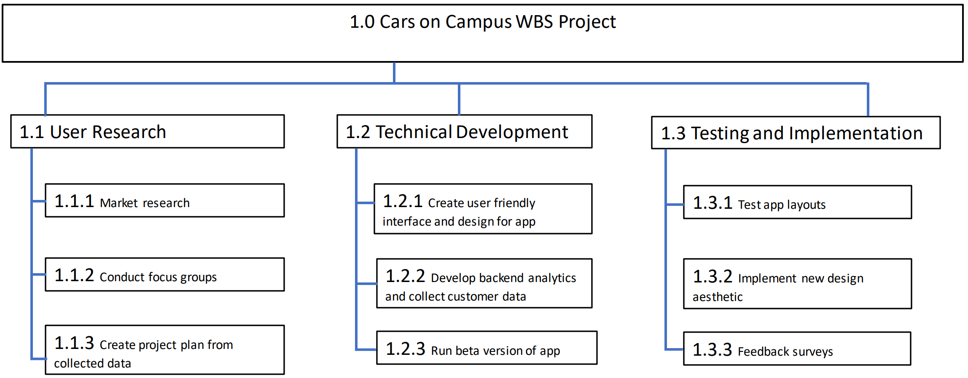

Business Process Model
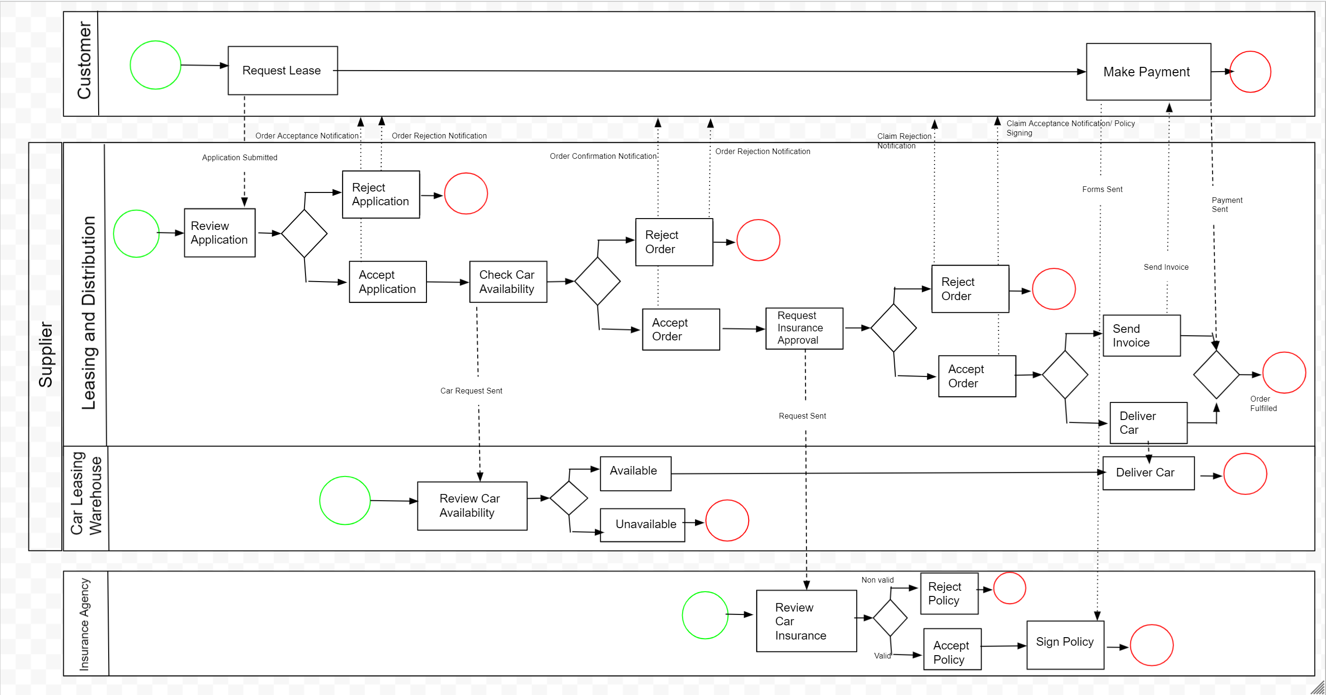

Application Wireframe Models
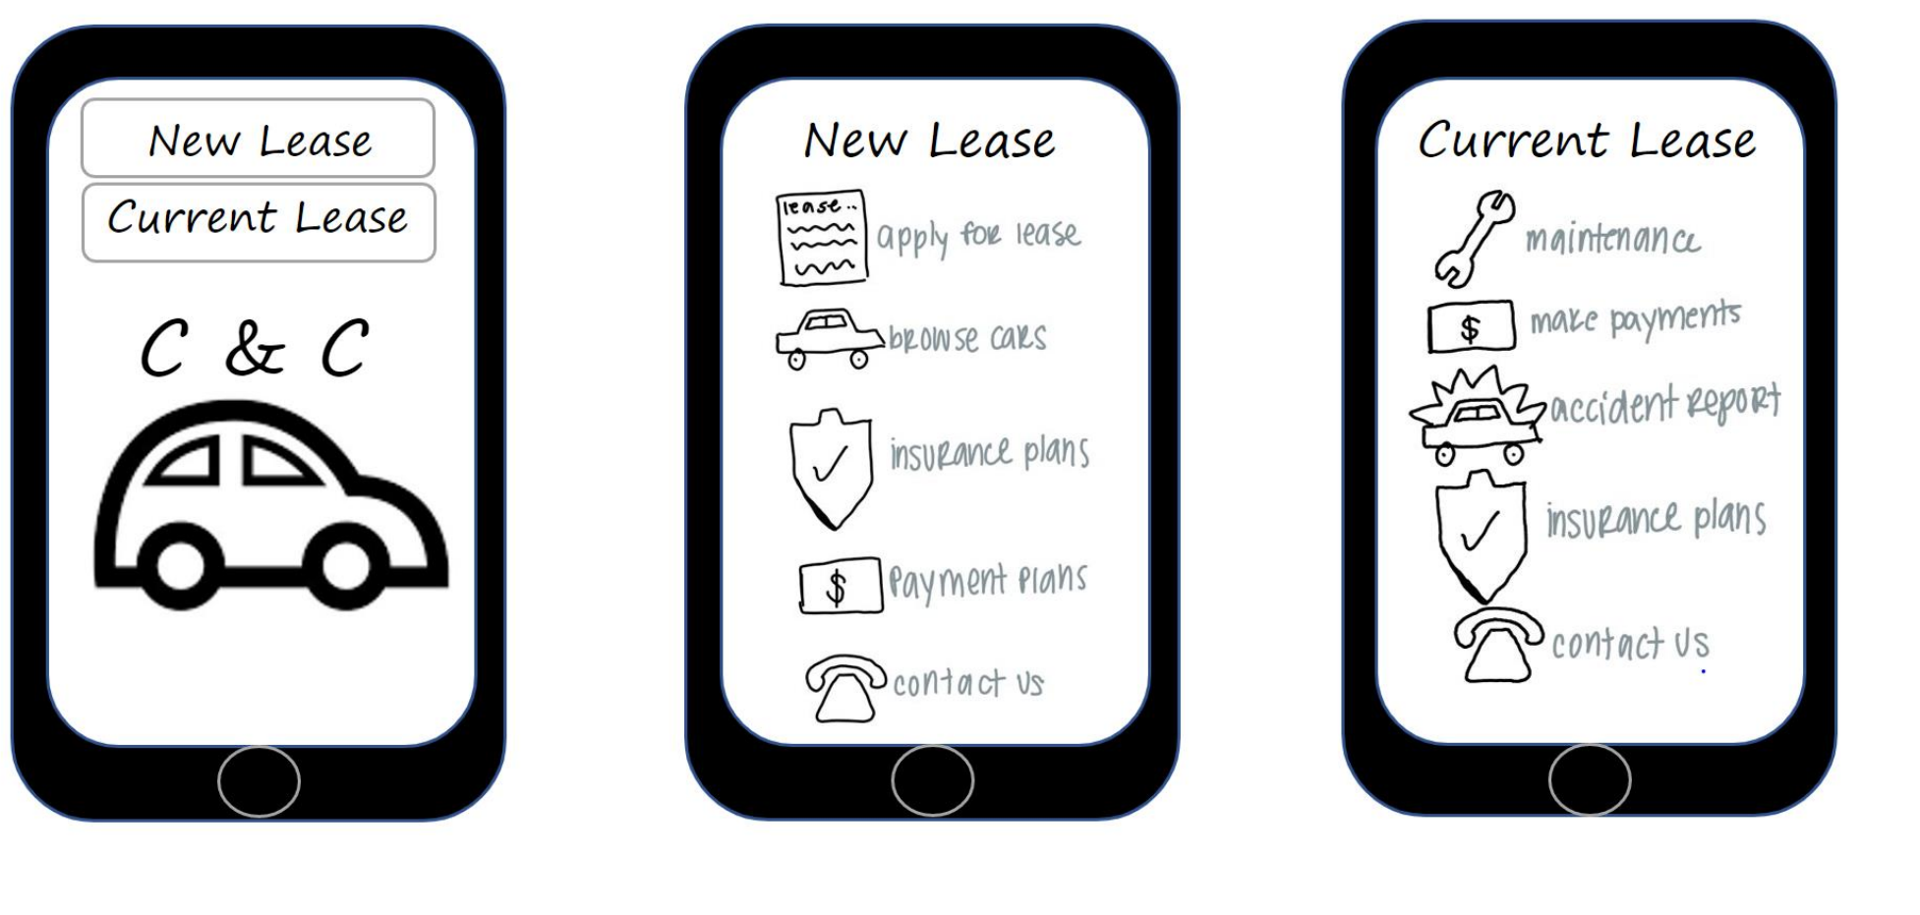

Data Management

Data Model

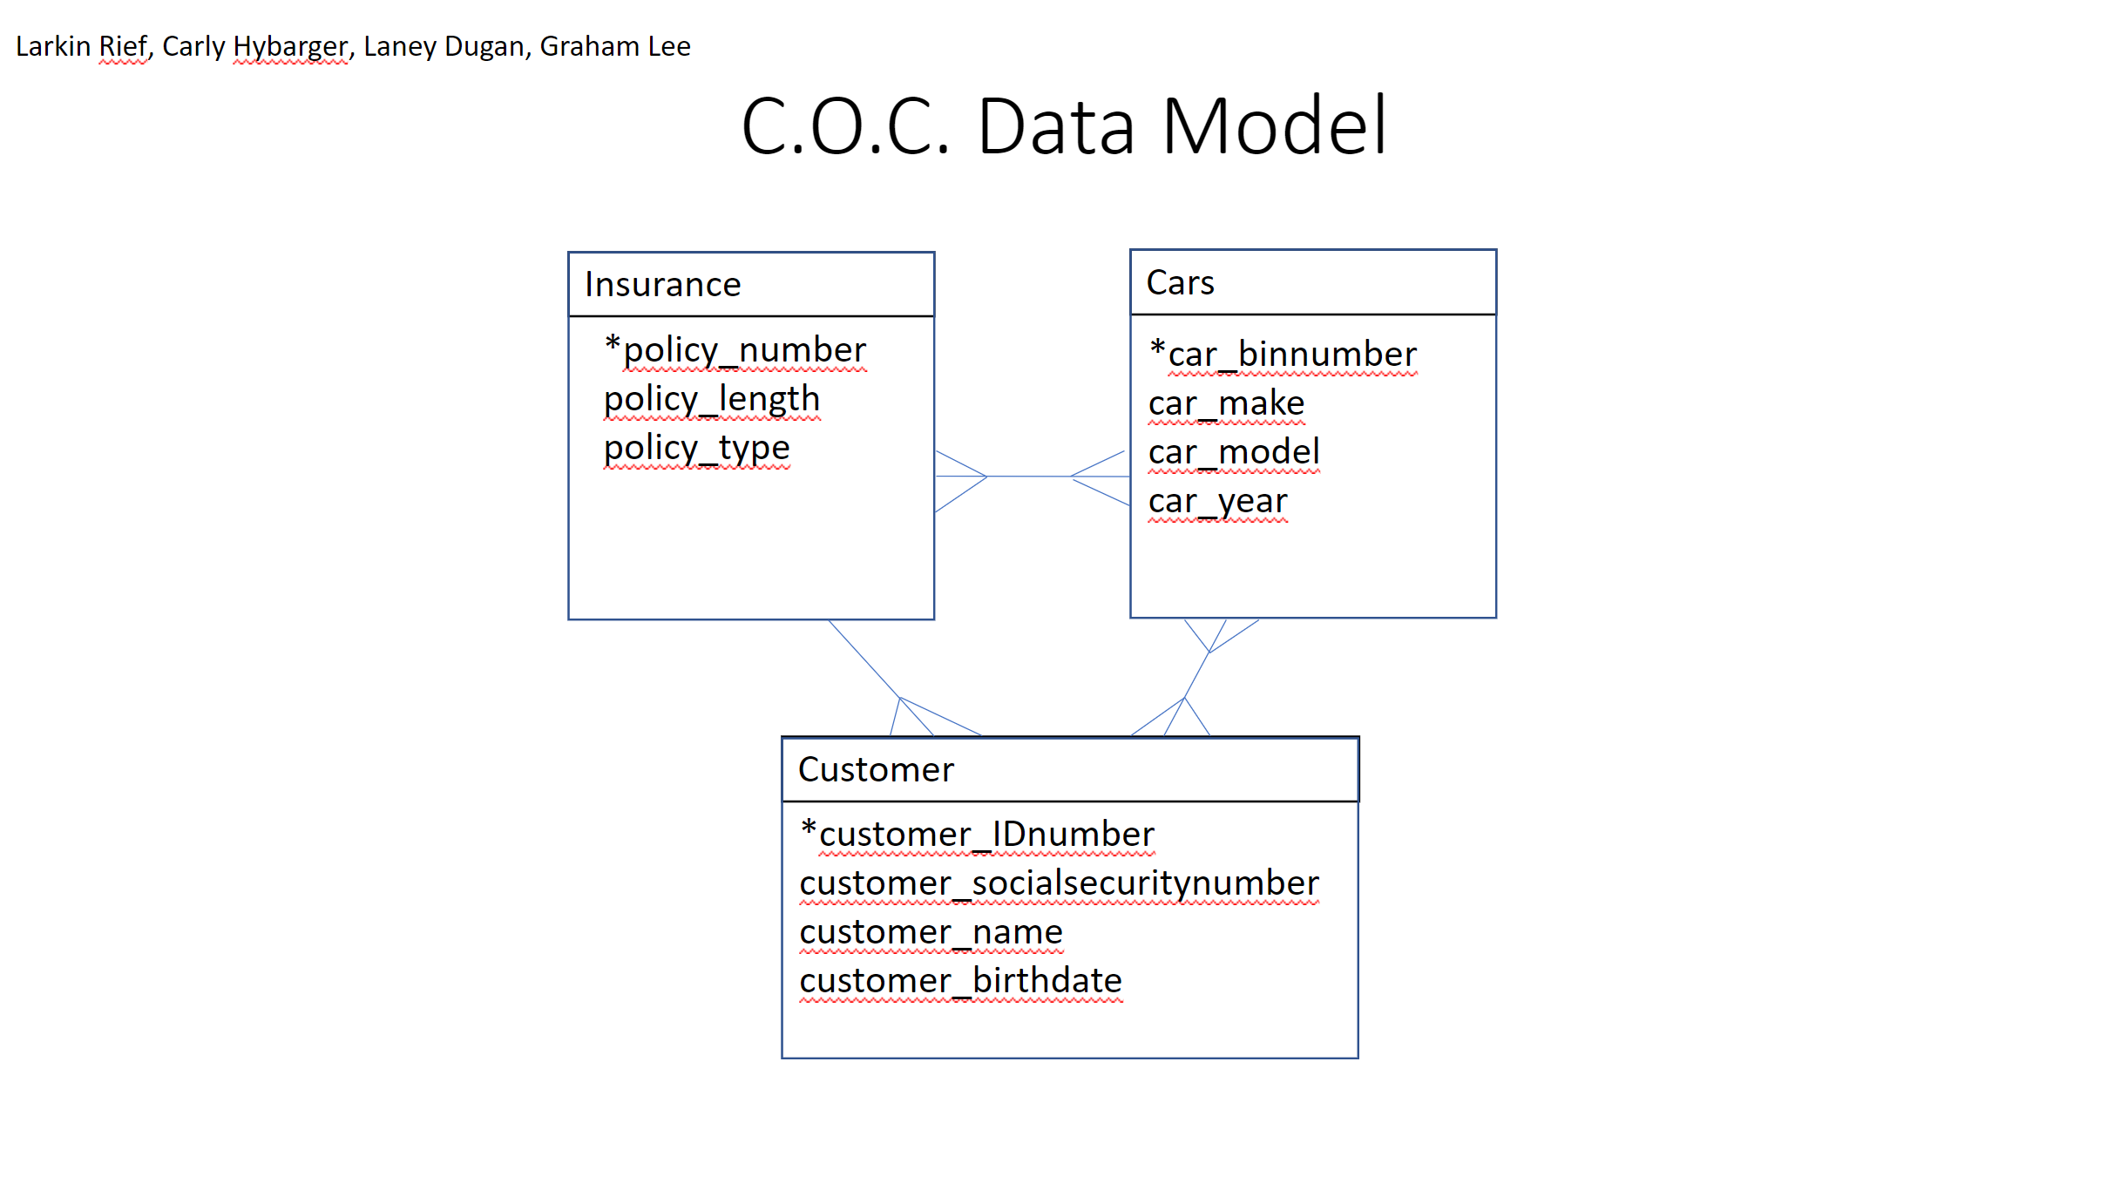

Written Explanation
The first entity in our data model is insurance. Each of our customers is required to have a valid insurance plan, so it is important that we keep track of this data. It is also necessary for our app because one of its big functions is to let customers view and manage their insurance plans.
The second entity in the data model is cars. The make, model, bin number, and year of the cars we supply are all very important to store. This data allows the app to differentiate between different customers’ cars so that they can properly report accidents or maintenance issues. The data is also imperative to the app’s car browsing function. Without this data, customers couldn’t see all available rental cars.
The final entity in our data model is customers. This entity is the backbone of the functionality of our app. Without storing identifying information about our customers, they would not be able to use the app to view their specific account. This data is used to allow customers to track their personal payments, insurance plan, and anything else that is associated with them individually.

Final Reflections
The most useful information that I learned from this lecture was the elements of the business model. With a future in business, understanding the fundamentals is vital in being able to make true contributions in the field. Similarly, discussing having work projects in resumes was very useful to know. The least useful thing that I learned throughout this first part of this course was learning about the sports analytics side of building effective information systems. Personally, I am not that invested in sports and am not concerned over the effect that IS can have over teams’ success. Additionally, I thought that the workload for this course was manageable. There were certainly lots of assignments and projects but keeping up with the due dates made it much easier to accomplish. This course changed the way I looked at Management Information Systems because I honestly did not know what it even entailed coming into the class. I rate the course an 8/10 and believe it will be very useful in my future.

